Variational Quantum Classifier (VQC)

1. Problem
In supervised classification, given labeled data points ((x_i, y_i)) with class labels (y_i {0,1}) (or multiclass extensions), the goal is to learn a decision boundary that correctly assigns labels to unseen data.
Classical classifiers (logistic regression, SVMs, neural networks) rely on optimizing parameters of a model. Variational Quantum Classifiers (VQCs) aim to perform classification by optimizing parameters of a parameterized quantum circuit.

2. Intuition
A VQC combines: - Quantum feature maps → embed classical data into quantum states - Variational (trainable) circuits → act like a quantum neural network - Classical optimization → updates circuit parameters
The quantum circuit produces measurement outcomes whose expectation values are interpreted as class predictions. Training proceeds in a hybrid quantum–classical loop.

3. Circuit Structure
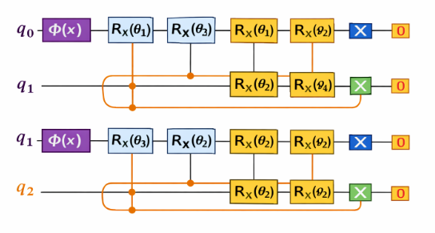
A typical VQC circuit consists of three parts:
- Feature Map
  - Encodes classical input (x) into a quantum state (|(x))
  - Uses parameterized rotations and entangling gates
- Variational Ansatz
  - Trainable layers with parameters ()
  - Contains rotations and entanglement
- Measurement
  - Measure one or more qubits
  - Expectation value determines class label
High-level flow:
[ x ;; |(x) ; |(x,) ; ]

4. Simple Math Involved
- Data encoding: [ |(x)= U_(x)|0 ]
- Variational circuit: [ |(x,)= U()|(x) ]
- Prediction (binary classification): [ (x) = (x,) | Z | (x,) ]
- Training objective: [ __i L(y_i, (x_i)) ] where (L) is a classical loss function (e.g., cross-entropy).

5. Python Code (Conceptual VQC – Qiskit)
import numpy as np

from qiskit.circuit.library import ZZFeatureMap, RealAmplitudes
from qiskit.primitives import Sampler

from qiskit_machine_learning.algorithms.classifiers import VQC
from qiskit_machine_learning.optimizers import COBYLA

X_train = np.array([
[0.1, 0.2],
[0.2, 0.1],
[0.8, 0.9],
[0.9, 0.8]
])

y_train = np.array([0, 0, 1, 1])

num_qubits = 2

feature_map = ZZFeatureMap(
feature_dimension=num_qubits,
reps=2
)

ansatz = RealAmplitudes(
num_qubits=num_qubits,
reps=2
)

optimizer = COBYLA(maxiter=100)

sampler = Sampler()

vqc = VQC(
sampler=sampler,
feature_map=feature_map,
ansatz=ansatz,
optimizer=optimizer
)

vqc.fit(X_train, y_train)

X_test = np.array([
[0.05, 0.1],
[0.85, 0.9]
])
predictions = vqc.predict(X_test)
print("Predicted class labels:", predictions)This code illustrates the structure of a VQC. Full training requires a classical optimizer and repeated circuit evaluations.

6. Where the Algorithm Is Useful
- Small to medium-sized classification problems
- Quantum machine learning research and benchmarking
- Exploring quantum advantage in non-linear decision boundaries
- Hybrid quantum–classical workflows

7. Limitations
- Training is slow due to many circuit evaluations
- Susceptible to noise and barren plateaus
- No proven quantum advantage for most datasets
- Requires careful circuit design
- Limited by current NISQ hardware

8. Comparison with Classical Classifiers
- Model type: Classical classifiers use explicit parameters; VQCs use quantum circuit parameters
- Optimization: Classical backpropagation vs. hybrid quantum–classical optimization
- Expressivity: Quantum circuits can represent highly non-linear functions
- Scalability: Classical methods scale better today
- Practical use: Classical classifiers dominate real-world applications

9. One-Sentence Summary
A Variational Quantum Classifier is a hybrid algorithm that learns classification boundaries by training a parameterized quantum circuit using classical optimization.

